Lisa M. Panahi, Bar No. 023421
General Counsel
State Bar of Arizona
4201 N. 24th Street, Suite 100
Phoenix, AZ 85016-6288
(602) 340-7236

IN THE SUPREME COURT
STATE OF ARIZONA
In the Matter of:  PETITION TO AMEND RULE 59(c) OF THE ARIZONA RULES OF SUPREME COURT | Supreme Court No. R-24-  PETITION

Pursuant to Rule 28(a) of the Arizona Rules of Supreme Court, the State Bar of Arizona (the “State Bar”) hereby petitions the Court to amend Rule 59(c) of the Arizona Rules of Supreme Court. The purpose of the amendment is to clarify the requirements of an application for stay pending appeal of a disciplinary sanction.
Background and Purpose of the Proposed Rule Amendment
Effective January 1, 2011, the Supreme Court promulgated Rule 59(c), Ariz. R. Sup. Ct., allowing for a stay pending an appeal of a disciplinary sanction. The rule provides that a stay pending an appeal of a disciplinary sanction shall be granted subject to appropriate conditions of supervision, except when an interim suspension has been ordered or when the hearing panel, in its discretion, determines no conditions of supervision will protect the public while the appeal is pending. See, Rule 59(c), Ariz. R. Sup. Ct. The rule did not include any specific requirements that a petitioner would have to establish to obtain a stay pending appeal.
On December 19, 2022, the Court issued an order in Gagic vs. Downey, State Bar of Arizona, Real Party in Interest, No. CV-22-0293-SA relating to a Petition for Special Action for Stay of Order of Suspension. The Court cited, “A party seeking a stay on appeal must establish the following elements: (1) a strong likelihood of success on the merits; (2) irreparable harm if the stay is not granted; (3) that the harm to the requesting party outweighs the harm to the party opposing the stay; and (4) that public policy favors the granting of the stay.” Smith v. Arizona Citizens Clean Election Comm’n. 212 Ariz. 407, 410-411 ¶10 (2006). These elements must be established along with appropriate conditions of supervision as set forth in the Rule.
The Supreme Court Rules should be sufficiently clear to allow a petitioner to understand the necessary elements of a petition for stay of a disciplinary sanction. Amending the Rule to include the specific elements would provide such clarification to petitioners.
CONCLUSION
The State Bar of Arizona respectfully requests that the Court amend Rule 59(c) of the Arizona Rules of Supreme Court as set forth in the attached Appendix.
RESPECTFULLY SUBMITTED this 10th day of January, 2024.

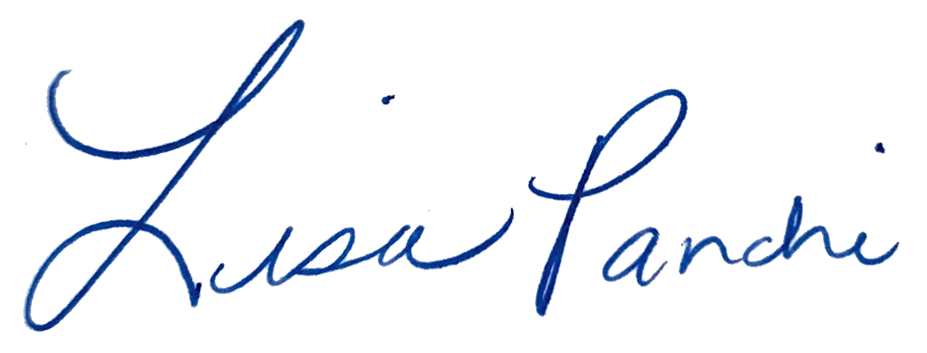
Lisa M. Panahi
General Counsel

Electronic copy filed with the
Clerk of the Supreme Court of Arizona
this 10th day of January, 2024.

by: PSeguin

These requirements were repeated in a subsequent order from the court on December 22, 2022, relating to an Amended Petition for Special Action and Request for Stay.

