Lisa M. Panahi, Bar No. 023421
General Counsel
State Bar of Arizona
4201 N. 24th Street, Suite 100
Phoenix, AZ 85016-6288
(602) 340-7236

IN THE SUPREME COURT
STATE OF ARIZONA
In the Matter of:  PETITION TO AMEND RULES 16(b) AND 30(b) OF THE ARIZONA RULES OF CIVIL PROCEDURE | Supreme Court No. R-24-  PETITION

Pursuant to Rule 28(a) of the Arizona Rules of Supreme Court, the State Bar of Arizona (the “State Bar”) hereby petitions the Court to amend Rules 16(b) and 30(b) of the Arizona Rules of Civil Procedure (the “Ariz. R. Civ. P.”) to address a witness’s remote appearance at a deposition. The proposed amendments to Ariz. R. Civ. P. 16(b) and 30(b) adopt changes to encourage attorneys to discuss early in the case whether they will agree to remote depositions, to provide notice of whether a party intends to take a deposition remotely or in-person, and to require the parties to meet and confer regarding multiple aspects of a remote deposition.
The attached Appendix A contains a copy of Rules 16(b) and 30(b) showing all the proposed changes to each rule. A clean version of each rule, incorporating the proposed changes, is attached at Appendix B.
- BACKGROUND
The Arizona Supreme Court’s Administrative Order 2022-46 (“AO”) very helpfully made recommendations for whether witnesses should be allowed to appear remotely for in-court appearances but did not address witness’s remote appearance for depositions. With the increase in witnesses appearing remotely for depositions, members of the Civil Bench and the Bar have raised concerns regarding the issues that arise over taking remote depositions and the means to avoid and/or resolve such issues. Rule 16(b) does not currently require the parties to discuss whether they anticipate holding remote or in-person depositions and Rule 30(b) does not currently require the party noticing the deposition to state whether the party intends to take the deposition in person or remotely. Rule 30(b) also does not require the parties to meet and confer regarding the details of taking remote or in-person depositions with sufficient time to bring any issues that arise to the trial court for resolution.
The State Bar’s Civil Practice and Procedure Committee (the “Committee”) created a subcommittee that discussed the appropriate notice and procedures parties should follow when discussing and noticing depositions to address common issues with taking remote depositions.
Accordingly, the State Bar believes that this Court should amend Ariz. R. Civ. P. 16(b) and 30(b) to clarify the notice and procedures parties must follow to address whether a deposition will be remote or in-person. The proposed amendments do not create or suggest a presumption or preference for either remote or in-person depositions.
II. THE PROPOSED AMENDMENTS TO RULES 16(b) AND 30(b)
The State Bar’s proposed amendments to Rule 16(b) require the parties to address at the Rule 16 early meeting whether the parties anticipate holding remote
or in-person depositions. While this is early in the case, by addressing the topic in
general terms at this early point, the parties will be able to identify whether the method of taking depositions may become an issue in the litigation.
The State Bar’s proposed amendments to Rule 30(b) require the party noticing the deposition to state whether the noticing party intends to take the deposition in person or remotely. If a deposition is to be held remotely, the State Bar’s proposed amendments to Rule 30(b) require the parties to meet and confer before the deposition, with sufficient time for the parties to raise any disputes with the court, regarding:
(a) how such deposition will be recorded,
(b) how exhibits will be exchanged and presented to the deponent at the deposition, and
(c) who may attend the deposition and how they may appear.
The State Bar’s proposed amendments to Rules 16(b) and 30(b) are brief but important to provide adequate notice to allow the parties either to agree to remote or in-person taking of depositions and to address any issues with such depositions.
CONCLUSION
The State Bar of Arizona respectfully requests that the Court amend Rules 16(b) and 30(b) as set forth in the attached Appendices.
RESPECTFULLY SUBMITTED this 10th day of January, 2024.

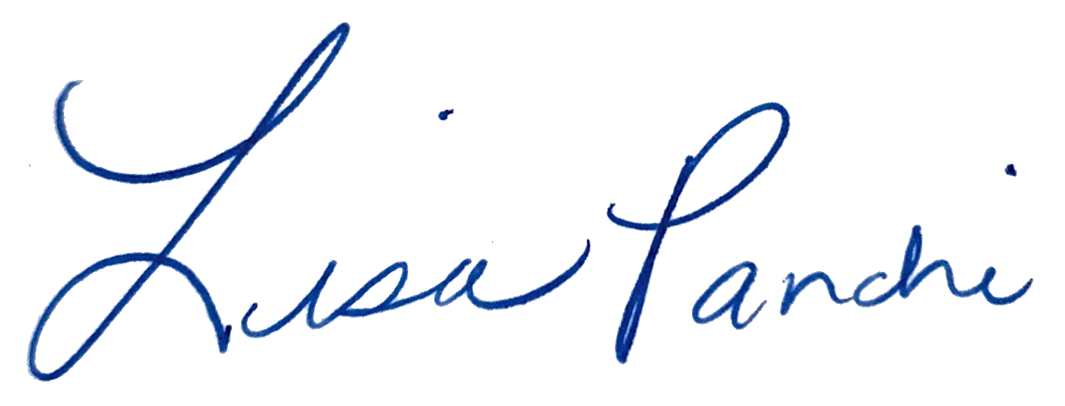
Lisa M. Panahi
General Counsel

Electronic copy filed with the
Clerk of the Supreme Court of Arizona
this 10th day of January, 2024.

by: PSeguin

A separate Petition filed by the State Bar during this rule petition cycle proposes additional amendments to Rule 16(b), but the two petitions address different aspects of the rule.

