Lisa M. Panahi, Bar No. 023421
General Counsel
State Bar of Arizona
4201 N. 24th Street, Suite 100
Phoenix, AZ 85016-6288
(602) 340-7236

IN THE SUPREME COURT
STATE OF ARIZONA
In the Matter of:  PETITION TO AMEND RULE 2 OF THE ARIZONA RULES OF FAMILY LAW PROCEDURE | Supreme Court No. R-24-  PETITION

Pursuant to Rule 28(a) of the Arizona Rules of Supreme Court, the State Bar of Arizona (the “State Bar”) hereby petitions the Court to amend Rule 2 of the Arizona Rules of Family Law Procedure (the “Family Rules”). This proposed amendment will clarify when and how certain Rules of Evidence, which do not normally apply in Family Court, may be enforced in family court matters.
Rule 2 of the Family Rules is titled “Applicability of the Rules of Evidence.” The rule provides that unless a party specifically files a notice, Rules of Evidence 602, 801-807, 901-903, and 1002-1005 do not apply in family court. The rule does, however, provide a method to notify the Court and the other party that a party wishes to have these Rules of Evidence apply in a specific case. This is often referred to colloquially as “invoking the strict rules.”
While Rule 2 provides for the timing of a notice that all the Rules of Evidence shall apply in a family court case, it does not address how such a notice affects some of the unique features of family law cases. For example, in other civil litigation, a complaint is filed, a trial may be held, and once there is a final judgment/appeal, the case is closed. If the same parties have another dispute later, they are required to file a new complaint, which is assigned a new case number. In contrast, family law cases can remain open for years, until all the children involved have been emancipated. Although the parties may have fully and finally resolved an initial petition for dissolution or to establish parenting time, they may later desire to modify those orders, or a new dispute may arise in this same matter. When that occurs, the new petition is filed under the same case number. The current rule does not specify whether a notice requiring compliance with the Rules of Evidence applies only to the pending matter or whether it requires such compliance until all the children have been emancipated. Moreover, as the judges and attorneys often change over the course of a case, they often may not know if a notice was filed many years and/or petitions ago.
The proposed addition provides a party with two options. The first option allows a party to file the notice and the notice will apply for all pending matters until their conclusion but will not apply to future modifications or enforcement hearings. Thus, if the parties later seek a modification or a new dispute arises, and a party wishes for the Rules of Evidence to apply, they will need to file a new notice. Alternatively, the proposed amendment to the rule provides parties with a second option to have the notice apply only to a specific hearing. The current version of Rule 2 does not specify whether the notice applies to all hearings in a pending matter or only to an upcoming hearing, which creates uncertainty.
Next, while some attorneys file a notice as a matter of practice, they may later find that the application of all the Rules of Evidence will not best serve the best interests of the children or a full presentation of the case. Often, attorneys for both sides agree that such rules should not apply despite a notice having been filed. While they have the option to agree not to object, without any written agreement, it is impossible to prepare for trial without knowing whether, in fact, such objections will arise. Under the current rule, there is no provision for a circumstance in which neither party wants all the Rules of Evidence to apply but a notice has been filed. The proposed amendment allows a notice to be withdrawn, but only upon written stipulation of both parties.
Finally, unique considerations pertaining to a type of hearsay–statements by children who are not permitted to testify in court–creates a complication in family court. Family Court is required to consider all evidence which is relevant to the children’s best interest. If the children at issue are of suitable age and maturity, then the court is also required by statute to consider their wishes. The court is also statutorily required to consider the children’s relationship with each parent, their siblings, and other significant individuals in their lives. Evidence regarding this information, however, generally constitutes hearsay and, under the current rule, cannot be used as evidence if a notice is filed. Thus, a parent against whom allegations of abuse or neglect are made will often file a notice as a strategic matter to prevent the court from hearing the children’s disclosures of such abuse or neglect, which is central to the case and to the children’s welfare. While options for a Child Interview (for children generally over 10 years) are available as are third-party reporters (at a cost), children will often not be open with strangers, particularly in a single meeting, about these issues. The children may have other evidence, such as e-mails or social media messages with or about their parents or concerns of safety with one of the parents or in their home. As written, the rule would exclude this evidence despite its importance in determining the best interests of the children. The court, therefore, is not able to fulfill its mandate to consider all relevant evidence.
A similar modification to admissible evidence regarding hearsay statements is found in the Rules of Procedure for the Juvenile Court. Rule 104 provides that “[i]n all adoption, dependency, termination, and Title 8 guardianship proceedings, evidence of a child's out-of-court statement or nonverbal conduct regarding acts of abuse or neglect perpetrated on the child is admissible if the time, content, and circumstances of the statement or conduct provide sufficient indicia of its reliability.”
The proposed amendments will provide clarity regarding the scope of a notice requiring compliance with the Rules of Evidence and will also ensure that even when such Rules do apply, the court is not deprived of critical evidence which it is required to consider.
CONCLUSION
The State Bar of Arizona respectfully requests that the Court modify Rule 2 of the Arizona Rules of Family Law Procedure as set forth in the attached Appendix.
RESPECTFULLY SUBMITTED this 10th day of January, 2024.

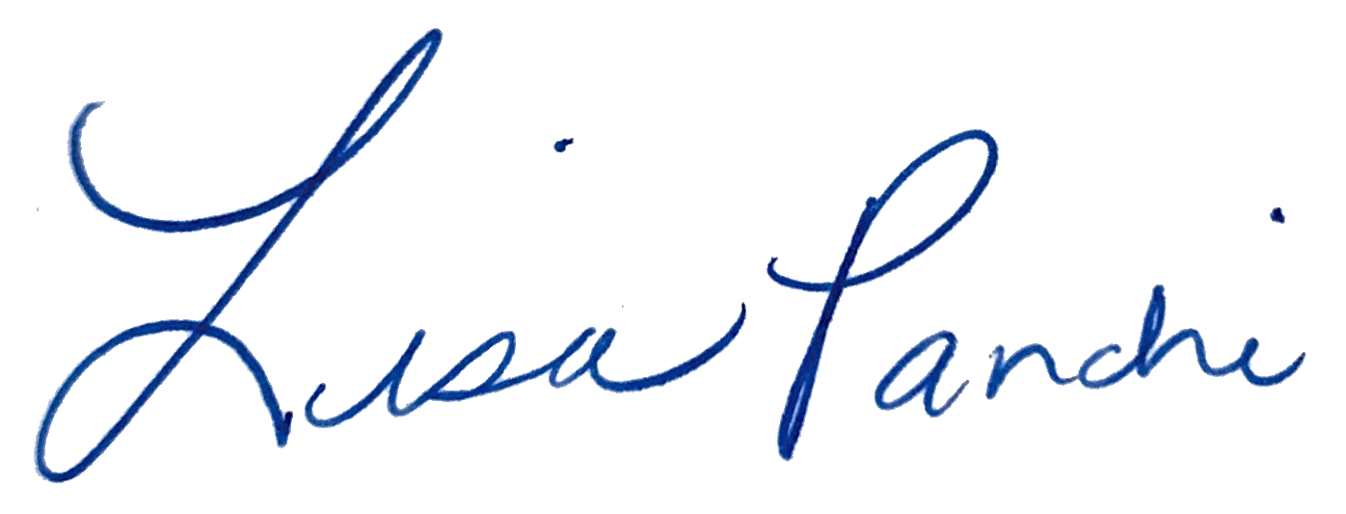
Lisa M. Panahi
General Counsel

Electronic copy filed with the
Clerk of the Supreme Court of Arizona
this 10th day of January, 2024.

by: PSeguin

