Lisa M. Panahi, Bar No. 023421
General Counsel
State Bar of Arizona
4201 N. 24th Street, Suite 100
Phoenix, AZ 85016-6288
(602) 340-7236

IN THE SUPREME COURT
STATE OF ARIZONA
In the Matter of:  PETITION TO AMEND RULE 16 OF THE ARIZONA RULES OF CIVIL PROCEDURE | Supreme Court No. R-24-  PETITION

Pursuant to Rule 28(a) of the Arizona Rules of Supreme Court, the State Bar of Arizona (the “State Bar”) hereby petitions the Court to amend Rule 16 of the Arizona Rules of Civil Procedure regarding the scheduling and management of actions. The proposed revisions will not significantly alter the substance of the current rule, but they will:
- provide clarity on the applicability of Rule 16(b) and (c);
- provide procedures for the parties in compulsory arbitration cases if they disagree as to the appropriate discovery tier; and
- alleviate administrative burden on trial courts by striking the word “proposed” from Forms 11(b), 12(b), 13(b), and 14(b).
The State Bar believes the proposed amendments will reorganize the rule in a minimally invasive way to bring some needed clarity to the rule and associated Forms.
Appendix A is a blackline of the proposed amendments to Rule 16 and Forms 11(b), 12(b), 13(b), and 14(b). Appendix B is a clean version.
- BACKGROUND.
This Petition originated when a member of the State Bar contacted the State Bar’s Committee on Civil Practice and Procedure and requested it consider an amendment to clarify the applicability of Rule 16(c)(8) to Rules 16(b) and 16(c). The member suggested that it is confusing to have the applicability of Rule 16(c) addressed within a subsection to Rule 16(c) itself. The Committee formed a subcommittee to consider this concern and whether any other clarifications should be made to Rule 16. During the work of the subcommittee, another query came in from the same member of the State Bar about striking the word “proposed” from the Forms associated with Rule 16. This suggestion came in response to an observation from a judge that the submission of proposed orders that include the word “proposed” in the caption results in the need for trial courts to modify every such order to delete the word “proposed” before issuance.
///
///
- THE PROPOSED AMENDMENTS TO RULE 16 AND ITS FORMS.
- Rule 16(c)(8)(A)
Rule 16(c)(8)(A) addresses the applicability of Rule 16(b) (about the required early meeting and tiering) and 16(c) (about the joint report and proposed scheduling order) to actions subject to compulsory arbitration. Rule 16(c)(8)(B) addresses the applicability of Rules 16(b) and 16(c) to actions seeking certain types of relief, such as change of name, enforcement of judgment, restoration of civil rights, etc.
The State Bar found there was merit to relocating Rule 16(c)(8)(A) and (B) for two reasons. First, as urged by the member of the State Bar who originated this suggestion, the inclusion of exceptions to the applicability of Rule 16(c) within Rule 16(c) itself has confused some practitioners. Second, the applicability of Rule 16(b) may be overlooked in its current location at the end of a separate and lengthy subsection 16(c). The State Bar member had suggested relocating these two subsections into a new Rule 16(d) and renumbering the subsequential subsections of Rule 16. The State Bar decided instead that the optimal place for these subsections would be in new subsections at the end of Rule 16. The proposed changes thus move current Rule 16(c)(8)(A) to proposed Rule 16(l) and moves current Rule 16(c)(8)(B) to proposed Rule 16(k). This placement at the end of Rule 16’s existing subsections – rather than relocating the provisions to a new Rule 16(d) – avoids causing a cascade of Rule subsection renumbering and also avoids requiring numerous court forms to be updated with new references.
- Rules 16(b) and 16(c)
In order to prevent these proposed Rule 16(k) and 16(l) subsections from being overlooked at the end of Rule 16, the State Bar proposes adding a brief preface to Rules 16(b) and 16(c): “Except as provided in Rule 16(k)” is added to Rule 16(b)(1) and “Except as provided in Rule 16(k) and (l)” is added to Rule 16(c)(1). These prefaces will alert practitioners to the fact that applicability of those rules is discussed later in Rule 16 and will direct them to the specific subsections.
- Rule 16(c)(1)
The State Bar proposes rearranging the first sentence of Rule 16(c)(1) for clarity. With the addition of the proposed preface to Rule 16(c)(1), the previous preface becomes ambiguous in its current position. Simply relocating the phrase “no later than 14 days after the Early Meeting” to the end of the first sentence restores clarity to the sentence.
- Rule 16(k)
Because this draft moves current Rule 16(c)(8)(B) to Rule 16(k) the actions listed are enumerated with numbers (1) through (13), rather than lowercase Roman numerals (i) through (xiii). The text of this section is otherwise unchanged.
///
- Rule 16(l)
The State Bar proposes adding a sentence to proposed Rule 16(l) to require the parties in compulsory arbitration to use the procedures in Rule 16(c)(6)(B) if they disagree as to the appropriate discovery tier. Current Rule 16(c)(8)(A) states that the requirements of Rule 16(c) do not apply to actions subject to compulsory arbitration. However, in examining Rule 16, the State Bar considered that the procedures in Rule 16(c)(6)(B) should be used by parties in compulsory arbitration if there is a discovery tier dispute. Proposed Rule 16(l) addresses this with the addition of a single sentence at its end: “The parties must use the procedures set forth in Rule 16(c)(6)(B) if they disagree as to the appropriate tier.”
- Forms 11(b), 12(b), 13(b), 14(b)
During the course of the Committee’s work, a suggestion came in to strike the word “proposed” from the title and caption of Forms 11(b), 12(b), 13(b), and 14(b). When practitioners use the current forms, trial courts must spend time editing proposed orders to delete the word “proposed” from the caption. This is a repetitive and needless administrative burden, especially when the orders might otherwise require no other edits before issuance. The State Bar believes that deleting the word “proposed” from the titles and captions of the forms will not cause confusion with actual issued orders because the proposed orders will be lodged and will not bear the judge’s signature until actually issued. Indeed, some practitioners already take it upon themselves to delete the word “proposed” from their proposed orders, which alleviates the administrative burden and has not caused confusion. Accordingly, revising the forms as proposed would help resolve the inconsistency among practitioners and reduce unnecessary administrative burden. For the sake of consistency, this draft proposes changing references to the “Proposed Scheduling Order” to “Scheduling Order” in the heading of Rule 16(c) and “proposed Scheduling Order” in the text of Rule 16(c)(1), 16(c)(2), 16(c)(3), 16(c)(4), 16(c)(7), and 16(h)(1)(E).
CONCLUSION
The State Bar believes the proposed amendments to Rule 16 will improve the structure of the rule, provide clarity as to the applicability of Rules 16(b) and (c), and reduce administrative burden on the judiciary. The State Bar of Arizona respectfully requests that the Court amend Rule 16 as set forth in the attached Appendices.
RESPECTFULLY SUBMITTED this 10th day of January, 2024.

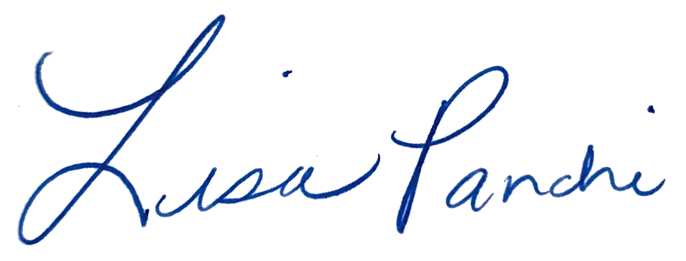
Lisa M. Panahi
General Counsel

Electronic copy filed with the
Clerk of the Supreme Court of Arizona
this 10th day of January, 2024.

by: PSeguin

