Gerald A. Williams
Arizona Bar No. 018947
North Valley Justice Court
14264 West Tierra Buena Lane
Surprise, AZ 85274

IN THE SUPREME COURT OF THE STATE OF ARIZONA

In the Matter of: ) Supreme Court
) No. R-23-0027
PETITION TO AMEND )
RULE 11(b)(1) ) Comment from Maricopa County
of the RULES OF PROCEDURE ) Justice Court Bench
FOR EVICTION ACTIONS )

BACKGROUND

This comment is filed on behalf of the Justice of the Peace Bench in Maricopa County. It was presented at a bench meeting on March 8, 2023, for discussion and then was endorsed by a unanimous vote of our bench at a bench meeting on April 12, 2023. We recommend the rejection of the proposed amendment.
This highly problematic rule change would impact every residential action filed in the state. It is an attempt to address the comparatively rare situation of a tenant being defaulted due to a problem interacting with court technology. When such a situation occurs, a tenant already has an existing legal remedy because a tenant can file a motion to set aside a judgment.

I.

THE RECOMMENDED CHANGE TO RPEA 11 IS CONTRARY TO JUDICIAL ECONOMY, WILL FORCE INEFFICIENCY, WILL MAKE COURT START TIMES IRRELEVANT, AND WILL MANDATE CHAOS.

The proposed amendment would command a case processing nightmare at least two days each week for Justice Courts in Maricopa County. If adopted, it would require judges to call every case twice. Once when scheduled and then again “after one hour has passed” or “at the end of the calendar.” (It is not clear what “at the end of the calendar” means, so the following example will use the one-hour requirement.)
Many, but not all, Justice Courts in Maricopa County schedule their eviction calendars in clusters by landlord attorney. A somewhat typical eviction calendar could have 15 cases filed by ABC law firm set for 1:00 p.m., 20 cases filed by DEF law firm set for 2:00 p.m., and 25 cases filed by GHI law firm set for 3:00 p.m. The information provided by the court, and served on the tenants, instructs the parties to call-in for their remote proceeding 15 minutes prior to the time it is scheduled. (See Attachment). On the computer screen, the judge can see how many people have signed into the system, and, perhaps after some announcements, will begin calling each case individually. (Contrary to the claim in the Petition, landlord attorneys have been appearing remotely in Justice Courts in Maricopa County for over two years.)
This typical afternoon moves forward. Of the 15 1:00 p.m. cases, four are dismissed after a verbal motion from the landlord. One alleges something other than only nonpayment of rent. The tenant disputes those alleged facts and the case must be set for a trial. Five tenants failed to appear and five involve tenants who admitted they have not paid their rent. None of those tenants dispute any of the amounts their landlord claims are due.
For the five tenants that did appear, the judge explains their remaining options, including possibly obtaining rental assistance; but also explains the writ of restitution process and the date the tenant may actually be required to move. (Some judges do this using some type of group rights advisement.) The 1:00 p.m. cases are done at 1:30 p.m. The only people listed as being present on the computer screen in the courtroom are the judge, a landlord attorney, and a court clerk. So what happens at this point if the proposed rule is adopted?
The 2:00 p.m. cases cannot begin at 2:00 p.m. because the judge must now call the five potential default cases that had been scheduled for 1:00 p.m., a second time. The first landlord attorney cannot represent his or her clients in another court at 2:00 p.m. because the 1:00 p.m. cases are being called a second time -- an hour after they were scheduled. The cases scheduled for 2:00 p.m. cannot begin on time and will now likely run into the 3:00 p.m. cases, which might now actually start between 3:30 p.m. and 3:45 p.m., after any potential defaults from cases set for 2:00 p.m. are called yet again at 3:00 p.m.
II.

ALLOWING REMOTE APPEARANCES FOR EVICTION ACTIONS HELPS SELF-REPRESENTED TENANTS AND INCREASES ACCESS TO JUSTICE

The Petitioners’ criticism of remote proceedings is perplexing. Their petition alleges:

During the COVID-19 pandemic, many courts proceeded to have telephonic or virtual hearings. The switch to remote court hearings only exacerbated problems for some low-income litigants, who often have limited access to the internet and other technology. Many courts in Arizona continue to conduct remote hearings in eviction actions. Petition to Amend Rule 11(b)(1), Arizona Rules of Procedure for Eviction Actions, No. R-22-0027, 5 – 6.

Courts in Arizona conduct remote hearings in eviction actions in large part because doing so is required by statute, by court rule, and by administrative order. While many self-represented litigants undoubtedly have either limited or no access to technology, internet access is not a prerequisite for a tenant to appear remotely for their residential eviction case. Only access to a telephone is required. More importantly, our remote appearance programs have been a remarkable success story.
One data-based example is the appearance rates in eviction actions filed in the Maricopa County Justice Courts. Before the pandemic, in more than one-third of evictions actions, the defendant failed to appear. In 2019, for example, the failure-to-appear rate in such cases ranged from one-third to approaching 40%. After implementing remote appearance options, failure-to-appear rates decreased significantly, to as low as approximately 13% in February 2021.

This trend has continued. By way of background, residential eviction filings typically drop considerably from January to February. In 2023, landlords filed 7,031 residential eviction cases in Justice Courts in Maricopa County. In February, there were 5,820 eviction actions; but the February data revealed two noteworthy points. First, February 2023 had more eviction cases filed than any other February in our history. Second, facilitating remote appearances continues to result in more tenants attending their court hearings. In February, only 24.4% of tenants failed to appear for their court date. In other words, three out of four tenants appeared for their eviction case. A belief that remote appearances have been a highly favorable change for tenants is usually undisputed. We are aware that some tenants may lack the technology or have other issues with technology; but they are still free to appear in person or by telephone. Again, we are puzzled how remote appearances can be viewed in any other manner than a positive one for litigants.
III.

COURTS SHOULD ENCOURAGE, NOT DISCOURAGE, PUNCTUALITY FROM LITIGANTS; BUT LITIGANTS WHO MISS THEIR COURT DATE HAVE AN EXISTING REMEDY

Although most justice courts attempt to accommodate people who appear on the wrong day at the wrong time in a variety of contexts, appearing on the
correct day at the correct time should be encouraged, perhaps especially given that litigants are now allowed to appear by phone. Even so, litigants who failed to appear, through no fault of their own, still have options.
The rules governing residential evictions in Arizona contain the well- established reasons someone can file a motion to set aside a judgment. Court employees are available to provide a self-represented tenant a form free of charge for this very purpose.
IV.
COURT RULES SHOULD BE NEUTRAL AND SHOULD NOT FAVOR ONE GROUP OF LITIGANTS OVER ANOTHER

Judges are mandated to be neutral and to exercise judicial functions with impartiality. If one side is specifically authorized to appear late, then the other side must be permitted to do so as well. Allowing every landlord and every tenant in Arizona to appear within an hour of their court ordered time is, at best, impractical.
Oddly enough, this also would require that a tenant, whose case would otherwise be dismissed and sealed, to have to remain in the hearing an extra hour (using precious minutes and data) to wait and see if the landlord does appear—all for the strangely specific reason of an alleged problem with technology. In addition, Justice Courts are very familiar with people representing themselves in courtrooms.
Since 2015, our bench has had a detailed Best Practice on Ensuring Access to Justice for Self-Represented Litigants in Civil Cases. Judges in Justice Courts routinely explain court procedures to self-represented litigants as well as what will likely happen next in the case. Each of us strive to make decisions based on the merits of a case, and not due to a default, whenever possible.

CONCLUSION
We respectfully request that the proposed amendment to Rule 11(b)(1) of the Rules of Procedure for Eviction Actions be rejected. It is a request for a decree to require court congestion. No court rule, in any context, requires a judge to give a one-hour grace period for one party (and not the other) to appear for a scheduled court date.
/
/
/
/
/
/

RESPECTFULLY SUBMITTED, this 13th day of April 2023.

/s/ Anna Huberman
ANNA HUBERMAN
Presiding Justice of the Peace
Maricopa County
Justice Court Administration
222 North Central Ave., Suite 210
Phoenix, AZ 85004

Attachment:
Court Information Handout

Attachment

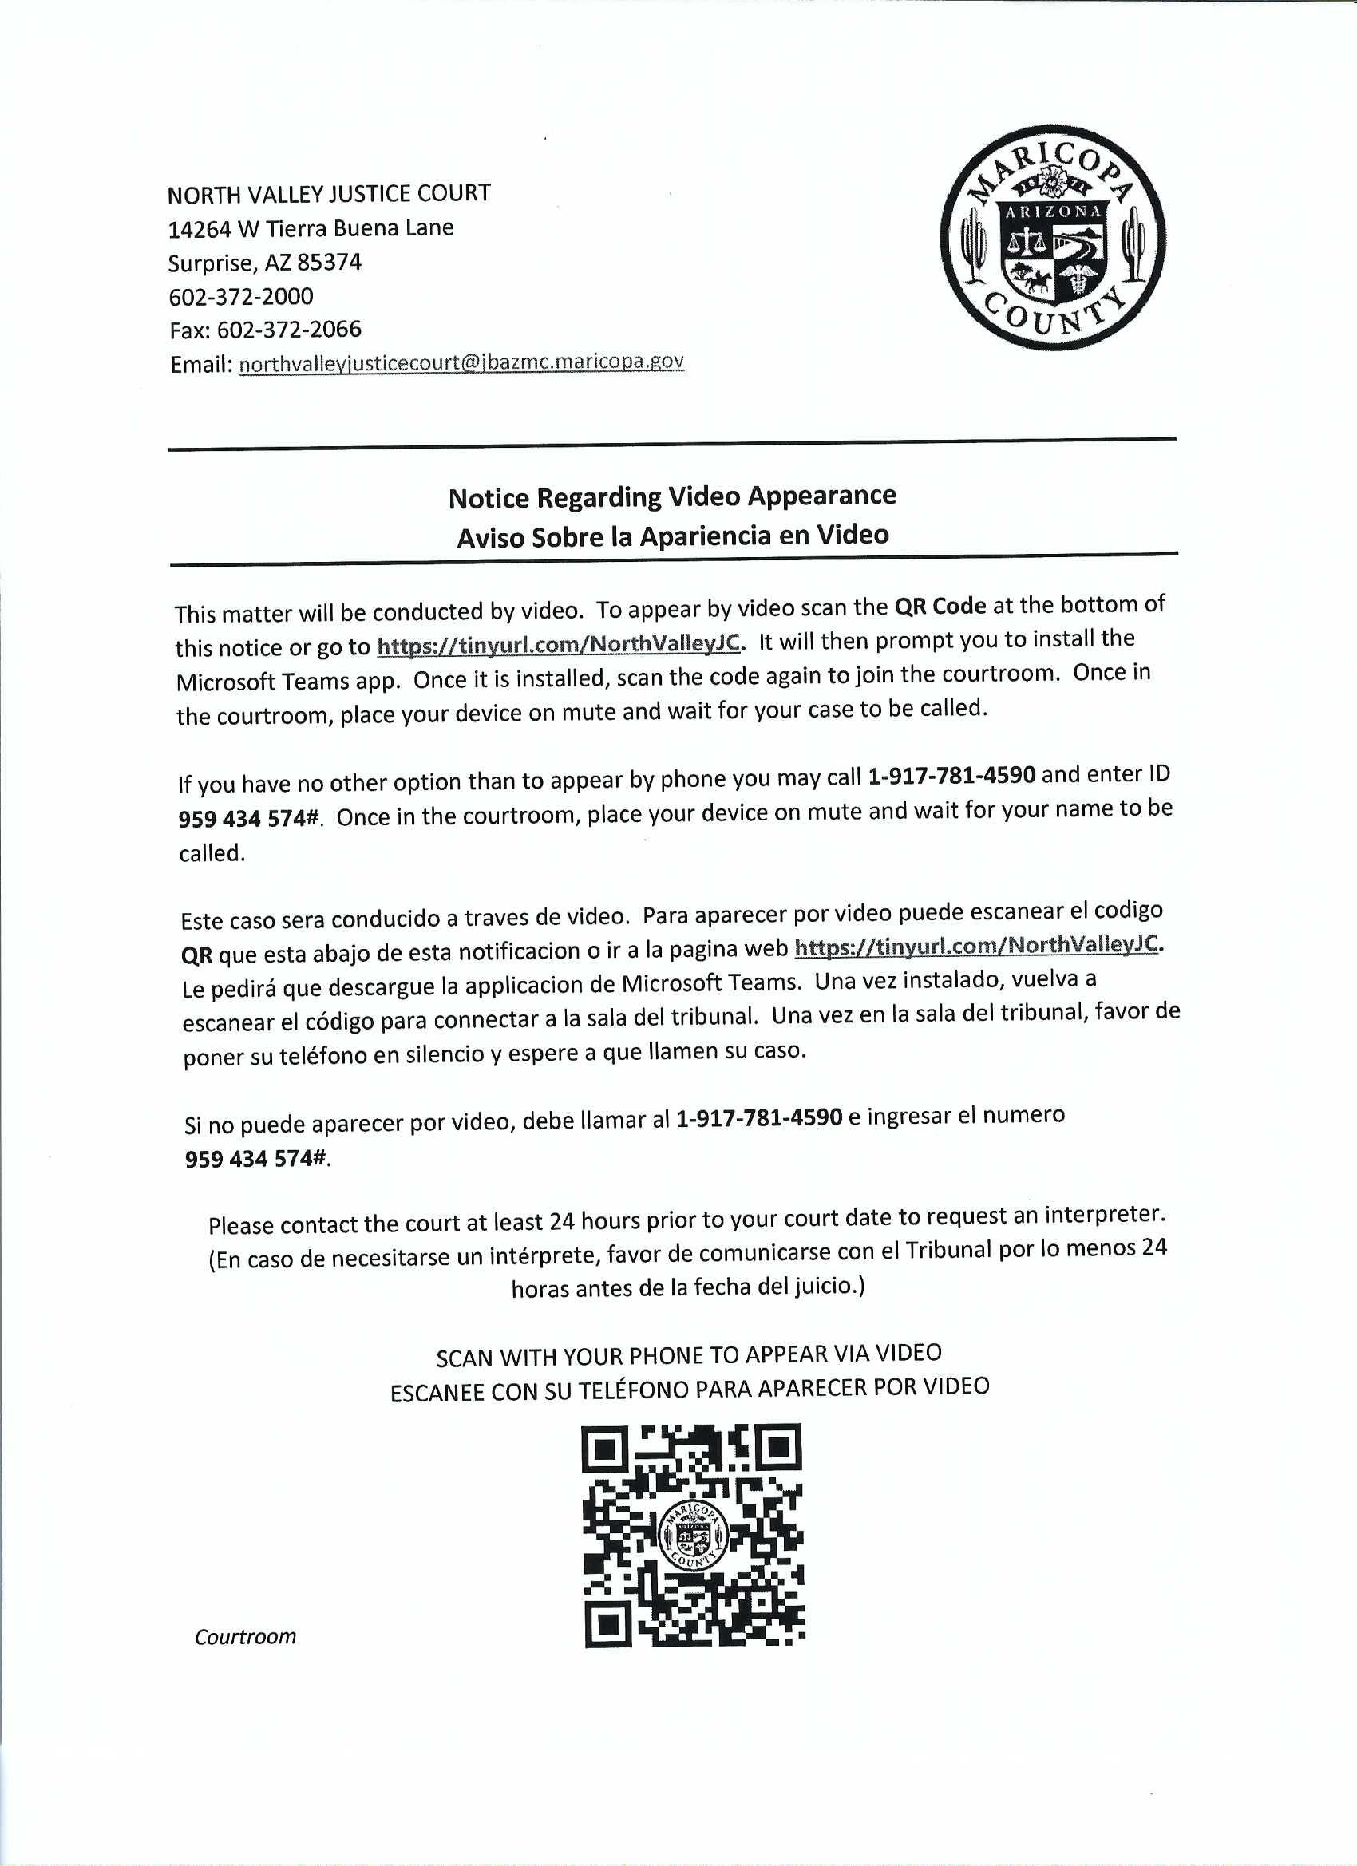

Every eviction judgment has two parts, an award of money and an award of possession. Most landlords, who are represented by counsel, have standard written post-judgment payment plans that allow the tenant to maintain possession.
A.R.S. § 22-206(A)
RPEA 6(a)(4).
In the Matter of: Adoption and Implementation of Plan B Workgroup Recommendations as Presumptive Standards for Remote and In-Person Hearings, Ariz. S.Ct. Admin. Order 2022-88 (Aug. 3, 2022); In The Matter of the Adoption and Implementation of Presumptive Standards for Remote and In-Person Hearings for Justice Courts in Maricopa County, Maricopa County Admin. Order 2022-119 (Sep. 20, 2022).
Hon. Samuel A. Thumma, et. al., Post-Pandemic Recommendations: COVID-19 Continuity of Court Operations During a Public Health Emergency Workgroup, 75 SMU L. Rev 1, 18-19 (Jan 2022). The quote is from the report of the Plan B Workgroup. Manistee Justice of the Peace (Maricopa County) Donald Watts served on that workgroup.
All of the data in this paragraph is from Scott Davis. He is the Communication and Public Information Officer for the Justice Courts in Maricopa County.
These include mistake, inadvertence, or excusable neglect. RPEA 15(a).
This Best Practice received the Chief Justice’s 2015 Strategic Agenda Award for Enhancing Professionalism Within Arizona’s Courts. Our bench also has the following relevant written Best Practices: Conducting Eviction Initial Appearances and Trials, Eviction Complaints That Do Not Substantially Comply Eviction Rules, Landlord Attorneys Hearing Eviction Cases As Pro Tem Judges, and Lease Break Fees (As An Unenforceable Penalty).

