Vice Chief Justice Ann A. Scott Timmer, Chair
Attorney Regulation Advisory Committee
Supreme Court of Arizona
1501 W. Washington St.
Phoenix, AZ 85007

IN THE SUPREME COURT
STATE OF ARIZONA
In the Matter of:  PETITION TO AMEND RULES 34, 35, and 36, RULES OF THE SUPREME COURT OF ARIZONA | )  )  )  )  )  )  )  ) | Supreme Court No R-22-0020  Comment of the Attorney Regulation Advisory Committee
The Arizona Supreme Court’s Attorney Regulation Advisory Committee (“ARC”) supports the petition to clarify the “good standing” requirement with respect to eligibility to sit for the Arizona Uniform Bar Examination and to clarify that an applicant aggrieved by a decision of the Committee on Character and Fitness does not have the right to file a reply brief in support of a petition for review to the Supreme Court for reasons explained in the petition.
RESPECTFULLY SUBMITTED this 29th day of April, 2022.
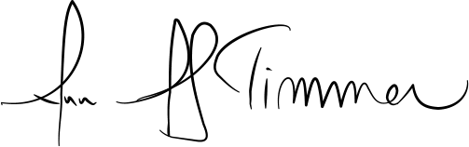

_____________________________________
Ann A. Scott Timmer, Chair
Attorney Regulation Advisory Committee

