Vice Chief Justice Ann A. Scott Timmer, Chair
Attorney Regulation Advisory Committee
Supreme Court of Arizona
1501 W. Washington St.
Phoenix, AZ 85007

IN THE SUPREME COURT
STATE OF ARIZONA

In the Matter of:  PETITION TO AMEND RULE 32, RULES OF THE SUPREME COURT OF ARIZONA | )  )  )  )  )  )  ) | Supreme Court No. R-22-0016  Comment of the Attorney Regulation Advisory Committee

The Arizona Supreme Court’s Attorney Regulation Advisory Committee (“ARC”) respectfully submits this comment regarding Rule Petition R-22-0016. ARC does not support the petition as written.
RESPECTFULLY SUBMITTED this 29th day of April, 2022.
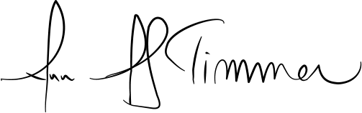
__________________________________
Ann A. Scott Timmer, Chair
Attorney Regulation Advisory Committee

