Vice Chief Justice Ann A. Scott Timmer, Chair
Attorney Regulation Advisory Committee
Arizona Supreme Court
1501 W. Washington St.
Phoenix, AZ 85007

IN THE SUPREME COURT
STATE OF ARIZONA
In the Matter of:  PETITION TO AMEND COMMENT 4 TO E.R. 7.1, RULE 42, RULES OF THE SUPREME COURT OF ARIZONA | )  )  )  )  )  )  )  ) | Supreme Court No R-22-0001  Comment of the Attorney Regulation Advisory Committee
The Arizona Supreme Court’s Attorney Regulation Advisory Committee (“ARC”) supports the petition to amend Ethical Rule (ER) 7.1, Comment 4 to reinstate the phrase “or retired” in the comment’s second sentence. The amendment will explicitly permit including the name of a retired member of the firm in a law firm’s name. ARC supports this change that reinstates wording unintentionally omitted from the original rule.
RESPECTFULLY SUBMITTED this 29th day of April, 2022.
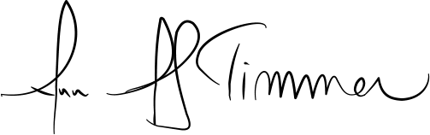

_____________________________________
Ann A. Scott Timmer, Chair
Attorney Regulation Advisory Committee

